MVP

# Donate a Mole Project

Design computing Studio3 – Building (DECO7381)

By Team CoolCoolCool

Shu-Jui Huang

De-Shin Li

Lu Cao

Weijian Chen

Jiechen Xu

Ling-Chieh Liu

Guoqing Chen

Yi Zou

Table of Contents

Cover Page 1

Product Overview 3

Code Guide 4

System Architecture Diagram 5

Reference Page 6

List of Figures

Figure 1: Melanoma cases by race and sex 4

# **Product Overview**

Our Donate A Mole project consists of two products. The main product of our project is a mobile app that collects mole images from people of all ages that use mobile phone. The other product is a web application for the researchers to collect the mole images. Since there are currently insufficient quality images and data available for researchers to analyse and research, the aim of this project is to collect as many mole images and detail mole information as possible from the general public. The purpose of collecting mole images is for Dermatology Research Centre to create a crowd sourced database of moles to analyse mole images and conduct further research on melanomas to reach our clients’ final goal: a world without Melanoma.

Our client had set the target users of this product at the beginning of the design process. There were two main intended users groups of our product. One of the primary user groups of our project is the Australian who are willing to donate the images of their moles for the research purpose. The other main user group of the project is the researchers in Dermatology Research Centre, which is also our client. The researchers will use the uploaded images and information to analyse and do the further research on melanomas.

The main intended users are the group of people that were most likely to be diagnosed with melanoma so that researchers can collect the most pictures of possibly melanoma mole pictures. According to Australian Institute of Health and Welfare 2017, “Australia and New Zealand have the highest melanoma rates in the world with Queensland incidence rate of 71 cases per 100,000 people (for the years 2009-2013), vastly exceeding rates in all other jurisdictions nationally and internationally.” “Melanoma is the most common cancer in young Australians (15–39-year-olds) making up 20% of all their cancer cases.” Besides, the National Cancer Institute states that White has the highest rate of getting melanoma (Figure 1).

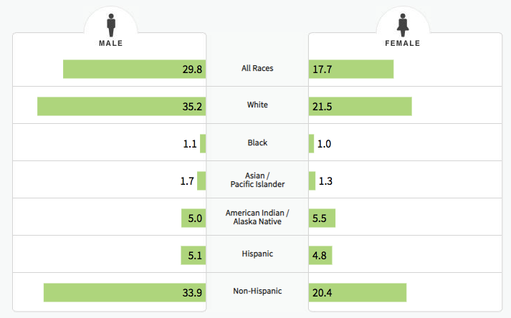

Figure 1: Melanoma cases by race and sex

The value our product delivers to the intended users including provide knowledge regarding skin cancer, help users to locate the nearest skin cancer clinic, and provide them a platform to record and observe the mole changes. Users are capable of inspecting the change of moles under a period of time through the donation history page if they submitting photos continuously and regularly. They are able to compare the changes of moles over the photos taken in the different time periods. If the users have the concern about their skin, they have the option to locate the nearest doctors for consultation through one of the app functions. Furthermore, this mobile application has a function of “fact of the day” that provide some information related to Melanoma for users to know more about melanoma and to raise the awareness of skin cancer. The value delivers to our clients (another user group) is helping them to collect enough mole images for their research purpose and to create a crowd sourced database of moles.

The following is the link to the MVP video.

# **Code Guide**

**Front-end**

The front-end contains the components of authentication, main and loading.

**The main component:** the main component divides into the app home page, donate and history parts. The home page component illustrates the view of the app, the donate component is to handle the camera and upload the images. The history component is to view the user’s history, users can create a new entry to upload a new image of a mole, or can view the old entries to view the upload history of a certain mole. There is another tiny function which is used for prefetching donation history and add history to the asynchronous function and reduce the images load time.

**The authentication component:** this component is associated with the login, signup, forget the password, reset password functions.

**The loading component:** This component requires asynchronous storage to detect if the user has login or not, if the user is login, the app page will jump to the home page, otherwise it will jump to the authentication component.

**API**

The API has the components of login, signup, forget the password, reset the password, history and donate.

**Login:** The users are trying to login, it is responsible for verifying if the E-mail and the password are valid.

**Signup:** Insert a new tuple in the user table if the E-mail is valid and not duplicated.

**Forget:** Send an E-mail which contains a link to the user request to reset the password.

**Reset the password:** reset the password.

**Donate:** Dealing with image uploading, an image upload request will pass the user id and the image file to the back-end, and the file will be uploaded so as the table will be inserted a new tuple, then let front-end know whether if the upload is successful.

**History:** Get the images uploaded by the user and pass them to the front-end.

**ER diagram**

There are four data schemas in the database which are the user, researcher, donation and note store, the ER diagram illustrates the relationship between these four entities.

Users use the App to donate the mole, each of them has a unique user id and provides the information about their name, login password, salt, E-mail id, phone number, date of birth, gender and ethnic. Researchers login the website to view the moles were donated by users and can make notes for each donation. Researchers also provide their name, login password, salt, email and last logged in time and privilege.

The mole has a unique donation id and the information of mole name, size, location, description, uploaded date and an image. A single mole is donated by a certain user and the user id is a foreign key link the donator with a certain mole.

Each mole has a note which is made by researches and recognized by the unique note id. The research id and donation id refer to the researcher and the donation respectively and linked a certain donation with the researcher. The note also contains the submitted date and additional information.

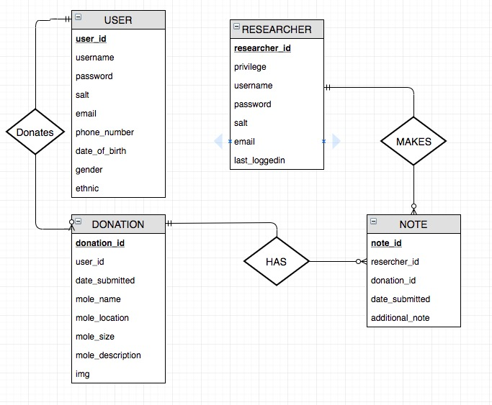

Figure 2 - ER Diagram

# **System Architecture Diagram**

The Diagram shows an entire view of our system which consists of four components such as front-end(mobile application and website for admin portal), API, and the Back-end Database, along with the interaction between each component.

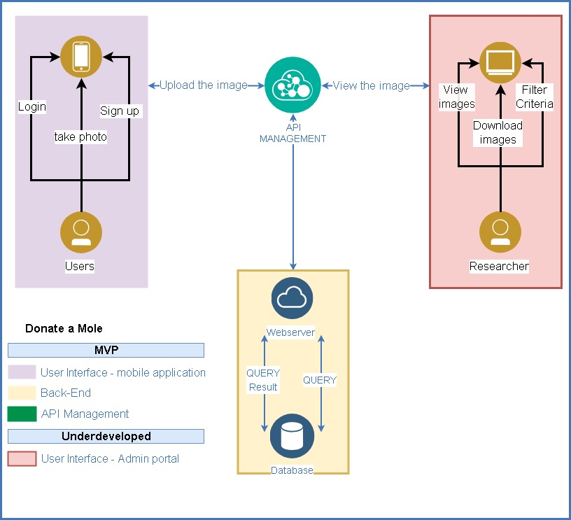

Backend

The Backend includes the PHP server and the Database, aiming to accomplish two functionalities as a mobile application app for Users and the admin portal for Researcher. The backend provides the interface that the requests could commute through it, it could store the image which uploads from the front-end users, then be reached by the front-end Researcher. By far, the PHP server has been settled on the UQ cloud and could retrieve the data from users who use the mobile application, then store the image, email address, and password of the individual user. Besides, the PHP server being able to identify users now. In addition, the backend has to provide an interface which researcher could read/write the donation information on the admin portal. The construction of the admin portal is not being involved in this term.

Front-End Users

The front end composes of two applications which are the donate a mole App and the admin portal. The purpose of App is gathering the images from users and then store it to the backend database. The user could review the history of their donations, however, they could not retrieve the image from the other donors. To-date, the fundamental function has been built, which user can upload their image via Donate a mole App, then the image can be reached on the database. The interface could distinguish whether the donor is the member or the anonymous by providing the login page to them. However, the admin portal for researcher has not been built yet, it will be implemented in the following weeks.

API

We use the PHP server to handle with the API, the external user will send a series of commands such as upload the image, sign up for the app, and forget their password. The back-end PHP server will catch these requests then convert it into sets of queries into the physical database. The PHP will distinguish those requests and give the different results. In order to protect the customer privacy, the API management should prevent the circumstance that the unauthorized user(as known as the donor) could retrieve the image which is not donated by them from the database.

**Functional Coverage Description**

The following lists the functional specifications of our final product that we have been discussed with our client that we intend to deliver at the end of the semester. Those functions have not yet been implemented are listed at the end of the page and have been greyed out.

* Sign up – Users are able to sign up for the account to get into the app donating the mole images.
* Log in – Users are able to log in to the app using users’ own username and password created at the sign-up stage.
* Reset password – In order to protect users’ password, users are not allowed to retrieve the password. Users can only reset the password when he or she forgot the password. The system will send a reset password email to the user’s mailbox for resetting email.
* Use phone camera takes picture and upload picture – Through the app, users are able to use his or she’s mobile phone camera to take the picture of moles and upload the picture.
* Upload picture through mobile phone album – Through the app, users are able to get access to the mobile album and upload the mole pictures that were taken previously.
* Profile page – Users are able to log in and create a user-profile page listing information regarding users’ age, race, sun exposure for researcher analyse purpose.
* Provide additional mole information – Users are able to provide additional mole information when uploading the mole images through fill in the additional information column.
* Access donation history – Users are able to compare the changes of moles over the photos taken in the different time period through the donation history page.
* Locate the nearest clinic – Users are able to locate the nearest clinic based on his or she’s current location.
* The Fact of the day – Users are able to learn more about skin cancer and melanoma through the function.
* Donate picture anonymously – Users are able to upload the image anonymously without login to maintain security and be confidential.
* Browse all images – Researchers are able to browse all donated mole images through the website platform.
* Special criteria filtering – Researchers are able to user criteria filtering images to select the specific images he or she is looking for.
* Download images – Researchers are able to download the images he or she wants for further analyse.
* Contact donor – Researchers are able to contact the image donors through the contact information donors provide when registering account if researchers want to learn more about the donor.

# **Reference**

* Australian Institute of Health and Welfare 2017.[Cancer in Australia 2017.](http://www.aihw.gov.au/publication-detail/?id=60129558547) Cancer series no. 101. Cat. no. CAN 100. Canberra: AIHW.
* National Cancer Institute, 2017. SEER Incidence and U.S. Death Rates, Age-Adjuster and Age-Specific Rates, by Race and Sex.